SECURITY SYSTEM WITH USER CHANGEABLE PASSWORD

ABSTRACT
The main objective of this project is to provide a security system having the provision to change the password by the authority only. The security of any organization or house is of prime importance always. The concern is for the physical property and also for the intellectual property in case of any organization. This proposed system provides a user friendly security system for organizations and homes. This system is password based and allows only authorized person to access it with a password. It also has the provision of changing the password.
The system is fully controlled by the 8 bit microcontroller of PIC family. The password is stored in an EEPROM and the password can be changed any time unlike a fixed one burnt permanently on to the microcontroller. A keypad is used to enter the password and a relay to lock or unlock the electric door, which is indicated by a lamp. Any wrong attempt to open the door (by entering the wrong password) an alert will be actuated, indicated by another lamp.
Further this project can be enhanced by interfacing a GSM modem to the device so that when a wrong password is entered, an alert SMS will be sent to the concerned authority.

BLOCK DIAGRAM
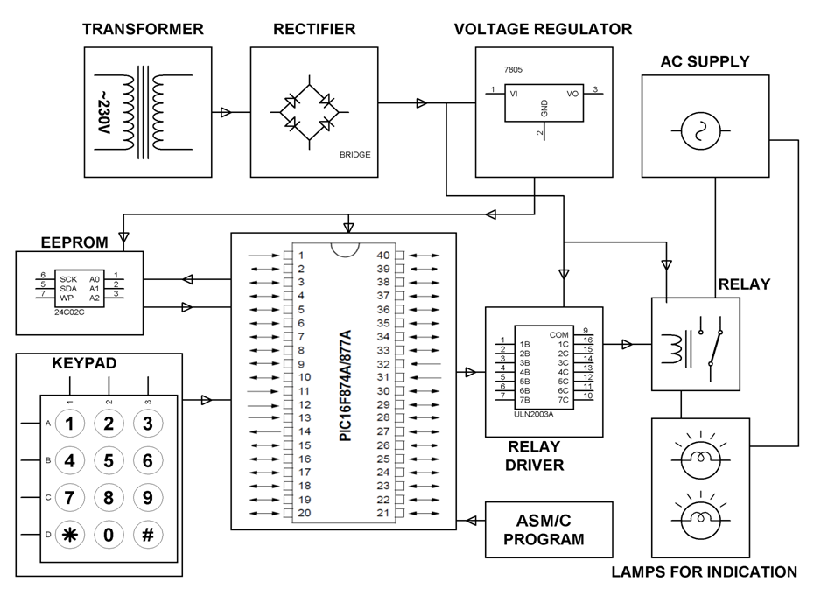

HARDWARE REQUIREMENTS:
PIC series Microcontroller, Relay Driver IC, Relay, Keypad, Resistors, Capacitors, LED, Diodes, Transformer, Voltage Regulator, Crystal, Lamps.

SOFTWARE REQUIREMENTS:
HI-TECH PICC Tool suite
Language: Embedded C or Assembly

